Running PT scripts through Jmeter

1. Open Jmeter click on Templates

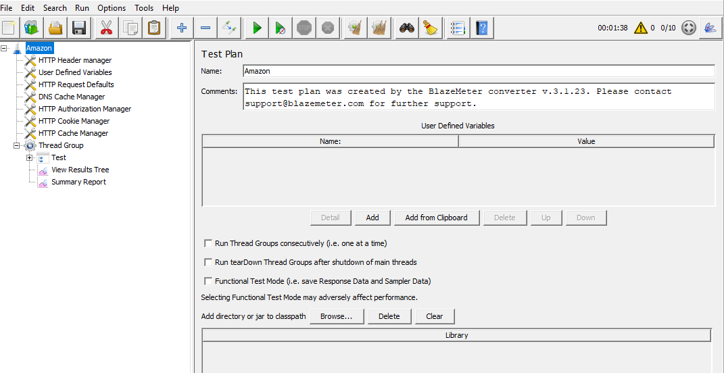

1. Select Recording with think time and click on create

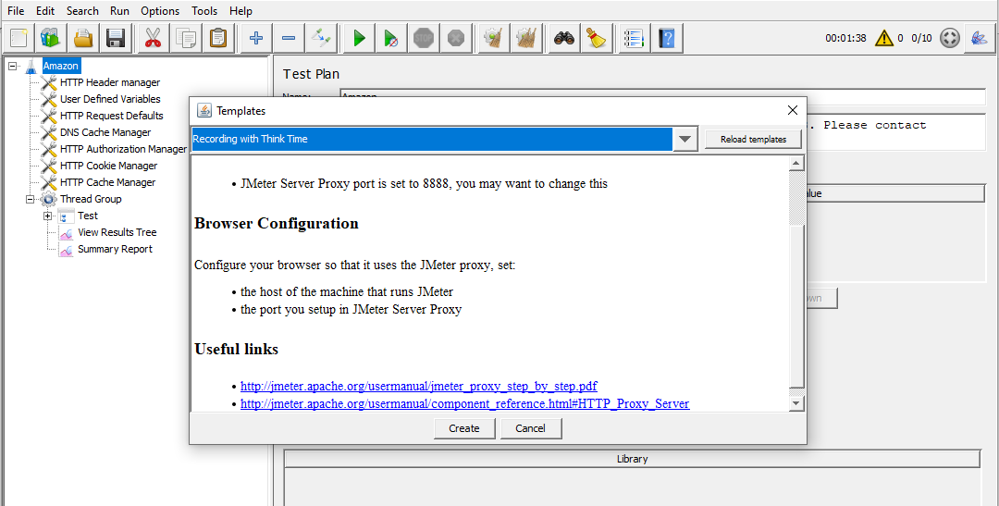

1. Save the thread group and open AMAZONPT.JMX file
2. Click on save and Run Scripts is of 10 user load can be increased load as per requirement